**DISNEY+HOTSTAR DATA ANALYSIS**

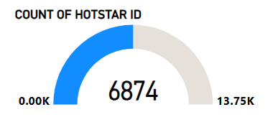

**Here there are 6874 Unique hotstar ID**

**1. Distribution of Movies by Genre:**

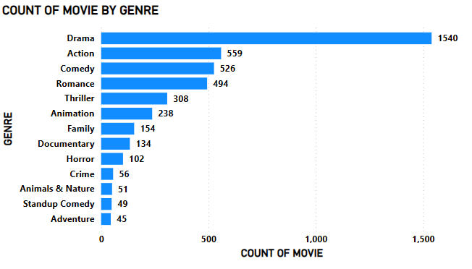

**In this Bar chart we came to know that Drama has 1540 movies, Action has 559 movie, Comedy has 526 movies and respectively**

**2. Average Running Time by Genre:**

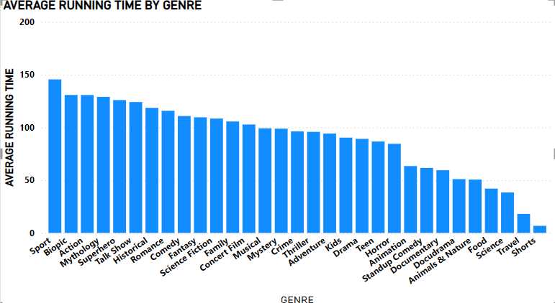

**In this Bar chart we know that average running time of each movie, From this Sport, Biopic and action movies are leading and Shorts is in least running time.**

**3. Movies Released Each Year**

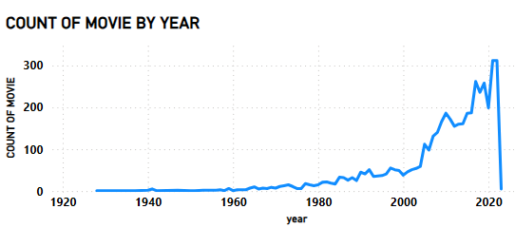

**In this line chart I have shown the movie released each year, In 1940 2 movies released , in 1960 1 movie released in 1980 22 movie released**.

**5. Movies by Age Rating:**

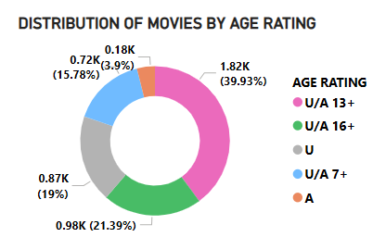

**Here I have shown the distribution of age Rating by genre**

**6. Count of Movies by Year and Genre:**

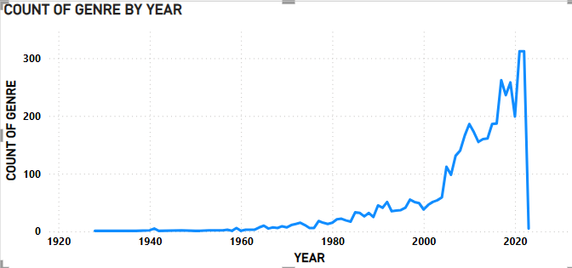

**Here I have shown the distribution of movies over the year**

**7. Most Common Movie Types:**

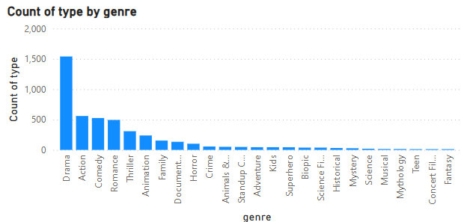

**In this Bar chart I have shown the types and count of each movies , Drama, action and comedy movies are leading and travel movie is being the least count**

**8. Correlation Between Running Time and Year:**

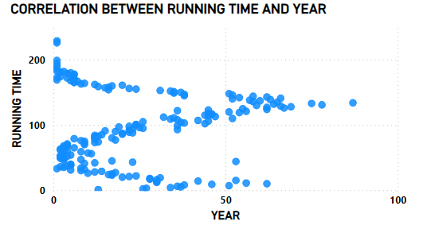

**Here the correlation between genre time running over the year.**

**9. Genre Popularity Over Time:**

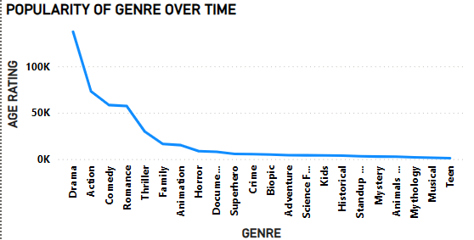

**In this line Chart I have shown the Popularity of Genre over time**.

**10. Movies by Genre and Age Rating:**

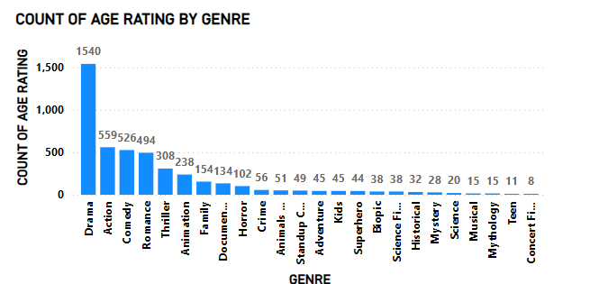

**In this Bar Chart I have shown the Age rating for each movie type, Here also Drama ,Action and comedy are leading and sports is the least one**

**11. Movies with Maximum Episodes:**

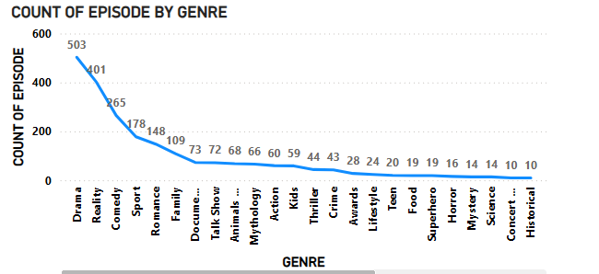

**Here in this line Chart I have shown the distribution of movie by maximum to minimum number of episodes , Drama, Reality and comedy movie have the maximum episode and Musical is being the least number of episodes.**

**12. Distribution of Running Time:**

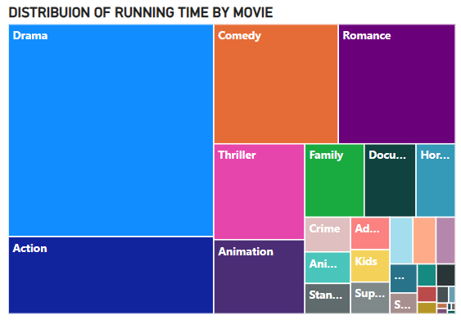

**In this tree map I have shown the distribution of Movie over running time**

**CUSTOMER FEEDBACK:**

Customers appreciate the vast content library, including Disney+ Originals, Hollywood blockbusters, regional Indian content, and live sports.

Many users express satisfaction with the **pricing structure**, especially the **VIP plan** that allows access to both sports and Indian content at an affordable price.

Availability of content in **multiple Indian languages** with subtitles and dubbed versions helps reach a broader demographic.

A frequent complaint is **buffering**, **lag**, or **downtime** during live sports events, especially when a large number of users are streaming simultaneously (e.g., during IPL matches).

While ads are expected in free-tier services, VIP-tier subscribers have voiced frustration over the **frequent ads** that appear during shows and sports, particularly when they have paid for the service.

Viewers have noted that the streaming quality and user experience can vary across devices. While the mobile version is optimized, some users report **glitches or slower load times on smart TVs** and **streaming devices**.

Issues such as **audio-sync problems** and poor resolution on bigger screens are common complaints.

**RECOMMENDATION**:

* Improve Streaming Quality and Stability for Live Sports
* Reduce Ads for VIP Subscribers
* Enhance Content Discovery and Personalization
* Expand Original Regional Content
* Introduce Flexible and Short-Term Subscription Plans
* Focus on User Interface (UI) and User Experience (UX) Improvements
* Expand International Market Presence
* Launch a Loyalty Program for Long-Term Subscribers

**DISNEY + HOTSTAR DOCUMENDATION**





